NSW Aboriginal Land Council

Freddy Fricke Scholarship Program 2015
APPLICATION FORM

PERSONAL DETAILS

Title (Mr, Mrs, Ms, Miss): Surname: Given Name: Other Names: Address:
Post Code: Date of Birth: Gender: Male Female Telephone: (Work) (Home) (Mobile) Email address: Local Aboriginal Land Council (where membership registered):

TAX FILE NUMBER:

- SCHOLARSHIP CATEGORY

Please indicate which Scholarship category you are applying for:

Category 1 Scholarship for Aboriginal student enrolled in a Diploma or Degree course.

Category 2 Scholarship for Aboriginal student enrolled in at Post Graduate course.

ACADEMIC INFORMATION

If you have commenced studying, applied or enrolled at a university please provide the following information:

Student Number:

Course: Qualification/Degree: Institution: Location/Campus: In 2015 the applicant will be completing year (insert relevant number)
of a (insert relevant number) year course.

Course Coordinator’s contact details:

Telephone: (Mobile)

Email address:

NSW Aboriginal Land Council Freddy Fricke Scholarship Program 2015 Application Form

- ACADEMIC HISTORY

Please provide details of your academic history to date. Please attach academic records and transcripts
as appropriate

5.1 Awards and achievements

- EMPLOYMENT HISTORY

Please provide information about your current employment (If applicable)
Applicants please note: Do you approve, if required, for your employer to be contacted

Yes No

6.1 Employment Details

Current Employer:

Current Position:

Manager Name & Position:

Office:
Manager Contact details:
Telephone: (Work) (Mobile)

Email address:

NSW Aboriginal Land Council Freddy Fricke Scholarship Program 2015 Application Form

7. TOTAL SCHOLARSHIP GRANT REQUESTED $
* NOTE: Maximum grant amount available is $5,000

7.1 | Approved University Course Fees | $
7.2 | Other approved related expenses  (Please specify or attach an itemised and costed list) | $

7.3 Details of other scholarships or awards (past and current) you have received
previously (if applicable)

8. PERSONAL STATEMENT OF SPECIAL ACHIEVEMENTS AND OBJECTIVES

8.1 Please write or attach a short summary of what you consider to be your personal and academic/career achievements to date:

NSW Aboriginal Land Council Freddy Fricke Scholarship Program 2015 Application Form

8.2 Please write or attach a short summary of your personal and career objectives for the future - in particular, please highlight any contributions you intend to make to your community and how you are motivated to succeed:

9. PRIVACY STATEMENT

The NSW Aboriginal Land Council and the Trustee of the CAF Community Fund acknowledge and respect the privacy of the Applicant. The information you provide on this Application Form is “personal information” as defined by the Privacy and Personal Information Act, 1998 (NSW) (the Act).

The information you provide is collected and held by the NSW Aboriginal Land Council and the Trustee of the CAF Community Fund in order to assess your application and for administrative and statistical purposes. The NSW Aboriginal Land Council and the Trustee of the CAF Community Fund will not disclose
your personal information without your consent and without due cause, except as required by law. You have the right to refuse this consent, but if the consent is not given your Application may not be processed. Your signature in Section 10 signifies your consent.

10. DECLARATION

I declare that the information supplied by me on this form and in its attachments is true, complete and correct. I understand that my application may rejected if I provide false or misleading information.

I authorise the NSW Aboriginal Land Council and the Trustee of the CAF Community Fund to obtain from the University I have attended or will be attending any and all details of my enrolment, academic record, examination results, including details of my enrolment variations and attendance.

I acknowledge that all decisions pertaining to the scholarship awards are at the total discretion of the NSW Aboriginal Land Council and the Trustee of the CAF Community Fund and I have no right to appeal any decisions made by them. I also confirm that I am Aboriginal and that I have provided one written statement from a recognised incorporated Aboriginal Community Organisation confirming my Aboriginality.

I grant the NSW Aboriginal Land Council and the Trustee of the CAF Community Fund permission to use details of any scholarship and awards I may receive for publicity purposes.

Signature: Date:

Print name:

Page 4

NSW Aboriginal Land Council Freddy Fricke Scholarship Program 2015 Application Form

11. CHECKLIST

 | Statement of Local Aboriginal Land Council Membership | Attached | Yes | No
 | Statement of Achievements and Objectives | Attached | Yes | No
 | Other Information including academic records and transcripts | Attached | Yes | No

Please retain all original certificates and keep a copy of your application because you may be required to attend an interview and produce documentary evidence/proof (ie original copies of certificates etc) to support your application.

12. COMPLETED APPLICATIONS

Completed Applications and supporting documentation must be received by the Freddy Fricke Scholarship
Program Administrator, CAF Australia, by:

5.00pm on Friday 6th February 2015

Address for Submission of Applications: For hand delivery:

Freddy Fricke Scholarship Program Freddy Fricke Scholarship Program
C/- CAF Australia CAF Australia
Locked Bag 962 Suite 1 - Level 10, 56 Berry Street
NORTH SYDNEY NSW 2059 NORTH SYDNEY NSW 2060
Telephone: 02 9929 9633

BY EMAIL:

freddyfricke@cafaustralia.org.au

Please note: Late Applications will not be accepted

Preference will be given to members of Local Aboriginal Land Councils and their children.

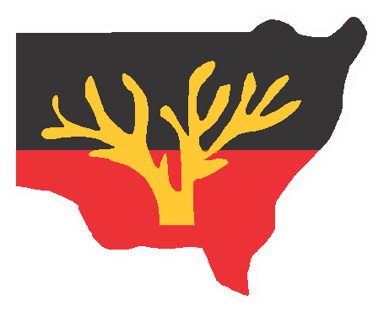

www.alc.org.au

